**1.0 Introduction**

Mrs. Apple Salonga, the Owner, was satisfied to plan a business on the side of the road, near through the stoplight, a store you can walk into. She named it Neneng’s Mini Mart Neneng’s Mini Mart is committed to satisfying customers by providing a broad selection of high quality and competitively priced products as well as exceptional customer service. But as the store grow upon its demands, One needs an improvement on overall systems.

A POS and inventory system can be as important for a small business as well for a large corporation. The key for a small business is that the POS and inventory system needs to offer functionality and configurability to flexibly address specific business needs and characteristics, and to enhance the business’ connection with its target market– a true differentiator for the business. POS systems are becoming prevalent for small businesses; of course, each vendor claims ease of use and significant benefits.

**1.1 Background of the study**

In our current age computer has truly become one of our daily life. It is also worth noticing that quite few of establishments do not use sophisticated systems to record transactions and record its inventory. Neneng’s Store situated in the inner streets of Calumpit Bulacan is a 1 year old store, a newly store indeed. Neneng’s store currently is the only convenient store like around the area there is no currently competition. And this is the also why many people come inside the store. Its because it only does not offer consumer products but it also provides as a place to hangout with.

Currently the store ways to record its transactions and inventories are done manually. The way they record transactions and inventory are in written form alongside with their sales reports. But this isn’t totally manual, In order for a convenient store to store its transactions and inventory they also have the aid of the Microsoft Excel. By the Excel functionality it can perform calculations through writing formulas through spreadsheets. And this spreadsheet will also act as a sales report. Our team proposes that Neneng’s store should have its own POS and inventory system as one. This is to provide more fluidity and efficiency.

As they plan on venturing to the changes and demands. The store needs to develop the way it process transactions. In order for a business to grow exponentially, one needs to change their way on how they tackle each goods and services towards the customers. That is why the store needs to have its POS and Inventory system. Currently the store uses excel and writing as the method of recording inventories. For a store that is growing they need a systematic of recording inventories, sales and transactions.

**1**

**1.2 Statement of the objectives**

The objective of the study is to change the store’s overall system and the way they record transactions, inventories as well as the way they generate sales reports. The other objective is for us to have a systematic overview of the POS system and how it works and operates. It is also its objective to give us a brief view on how businesses transactions works.

**1.2.1 General Objective**

* To develop a computerized Inventory system and POS for Neneng’s Mart that will help and make their transactions and inventories fast, smooth, and secured.

**1.2.2 Specific Objective**

* To develop a module that will easily monitor the stocks and to generate a sales report. This will create a module where it monitors the transactions fast and easily to eachproducts inside the storage/stock room.

**1.3 Significance of the study**

As stated over the chapter of statement of the problem. It proves that something needs to change in order to grow a business. It starts by changing the way to record business transactions. By providing them the POS system it will allow more fluid and systematic recording of inventories, sales, and transactions.

The significance of this study to Neneng’s Mart is that it will provide easy-to-useand easy-accessed system thustransactions will be more reliable and faster. Thus eliminating the manual way of recording transactions. It gives more accurate and secure records of sales and list of products. Will benefit the following.

• Admin/Owner: Manages the adding of stocks, updating the inventory, and determining the users of thesystem.

• Customers: Will have the benefits of the printed receipts right after purchasing an item.

• Future Researchers: would see the possibilities of upgrading the system.

•Researchers: student, teacher, programmer and web-developer can benefit in this systemthrough a detailed document.

**2**

**1.4 Scope and limitation**

**Scope**

* Security- The system has a capability to secure and retrieve a password of admin/user if he/she remembered their pin code.
* Inventory - The system has a capability to easy to inventory the all product in the Storage room.
* Generation of report -The system has a capability to accurate generation of reports
* File Maintenance-The system includes file maintenance that would automatically add, delete, save, Update, and retrieve information of the recordings of customer transactions and inventory records.
* Audit trail

**Limitation**

* No major credit card transaction during payment ,only cash payment
* No barcode reading.

**2.0: Methodology of the study**

[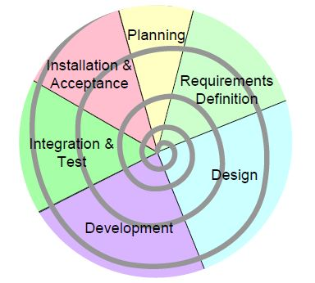](https://www.google.com/url?sa=i&rct=j&q=&esrc=s&source=images&cd=&cad=rja&uact=8&ved=2ahUKEwjUxrfutN_cAhUMYo8KHa1HCAQQjRx6BAgBEAU&url=http://www.itportal.in/2011/09/software-development-life-cycle-sdlc.html&psig=AOvVaw1NpVFUH_fxbz7KZs6KrT7i&ust=1533884507684304)

Spiral Method (fig.1.0)

We used spiral method as a means of our research methodology mainly because of it is a risk-driven model which means that the overall success of a project highly depends on the risks analysis phase. Risk analysis is specific expertise on every iteration. Thus, to review and analyze the project from time to time, special skills are needed. Our development in Spiral-SDLC model starts with a small set of requirement and goes through each development phase for those set of requirements. Our team adds functionality for the additional requirement in every-increasing spirals until the application is ready for the production phase.

**3**

**Planning phase**: As we will be making POS system. Our group researched ways on how to develop a proper POS system. Through research and brainstorming we only not managed to know how to develop but we also found our client with our project.

**Requirements definition**: Through handing out questionnaires and knowing the results of it. The group will figure out on what they truly demand over the system. This includes their asked designs and the overall feature of the POS system.

**Designing Phase**: Includes both the overall architecture of the POS system and the design of its User interface.

**Development phase**: Our group decided to split up the tasks to ease up the tasks of each members to allow a faster progress over our project. Two of the group members should handle the programming and designing phase while the other half will focus on documentation and other workloads.

**Integration and testing**: This comes after our development team concerning the programming and design had finished in creating the POS system. The group will send one of our prototypes to our client and make their feedbacks and suggestion. By doing this we can debug any errors easier and clearly.

**Implementation and Acceptance**: The final phase with the final product in line ready for private use. This also includes maintenance and updates over the system

**3.0 DATA GATHERING PROCEDURES AND OUTPUT**

**Interview**

Through one of our members Dave Mejares, Our group found its client to our POS system. Neneng’smart is a recently opened convenient store located in Calumpit, Bulacan situated inside a densely populated community. We interviewed Mrs. Apple Salonga the owner of the store. Said that owning a business is easy but running a business is not. We would think twice to hire a person to operate our business and make sure they are doing it right. But she saidIn this era of time, the common thing we have with everyone else is the computers. Automated programs and software is what makes everything so simple and easy. It is less of a burden now that we are able to complete a certain task in a few minutes.

That's why our Group created a POS system to help the mini mart workers works easily. The POS system can track sales by various payment methods like cash, checks, credit cards, coupons, and gift certificates. It requires accounts receivable and Inventory modules. For example, POS will update inventory sold figures in Inventory, or the salesperson’s commission in Accounts Receivable.

**4**

**OBSERVATION** This report is based on research initiated to determine the potential role of observation methodology in market plan development. This report is based on observations conducted on Neneng’s Mart. There are advantages to simplifying the collection of research data. Yet there is also a need to maintain a level of validity in the research result. Many times there is a need or desire for mini store management and/or employees to conduct research in order to obtain information in a timely and effective fashion.

In the retail business, a good point of sale system is one of your biggest assets. If it works as advertised, it’ll be a lot like having your own team of experts working behind the scenes, making sure everything’s moving along quickly and efficiently. To remain on top in today’s highly competitive retail landscape, you need a POS system to help you run your business the right way here’s why.

* It can save you time.
* Speed up Inventory management.
* Faster payroll processing.
* No need to dig through receipts.

**Chapter 4: The existing system**

**4.1 Company Background**

Neneng’s Mart is a newly opened store located inside the inner streets of CalumpitBulacan. The store is opened to the public last year (As for this scope of documentation.) Mrs. Apple Salonga saw an opportunity to build a general store. It is due to the fact that the community is growing in numbers. General stores can sell a variety of products than a Sari – sari store can offer it also provides a place where customers can hang out after buying snacks or other stuffs. Currently the store equips only 2 racks. Racks where they place their products offered. The store is only at their beginning phase they plan to expand their range of products and a variety of services they offer.

**4.2 Description of the current system**

Neneng’s Mart currently implements the “Manual” way of recording transactions and it’s inventory(stocks). The “Manual” way has its own advantage one is that it is simple to record especially if it has low number of items. Small businesses typically will keep its transactions and inventory manually. The mini mart uses Microsoft excel in recording their inventory(stocks).

**5**  
Inventory software programs now on the market let you track usage, monitor changes in unit money costs, calculate when you need to reorder, and analyze inventory levels on an item-by-item basis. You can even control inventory right at the cash register with point-of-sale (POS) software systems. POS software records each sale when it happens, so your inventory records are always up to date. Better still, you get much more information about the sale than you could gather with a manual system. By running reports based on this information, you can make better decisions about ordering and merchandising.

**Chapter 4.3 Data flow diagram**

Cashier

Customer

Figure 2.0

Data flow diagram

Profit

Transaction

Product info

Add product info

Save transaction

Process transaction

Payment

**4.4 Data Dictionary**

**•Account** - An account that is established to allow for regular business dealings or services.

• **AverageCost** - Refers to the average amount that has been paid for the items that are currently on hand. Prices for inventory items vary, and average cost gives a retailer an idea about how much he typically spends for any given item.

• **AverageQuantity** - Refers to the typical quantity that is on hand for any given item. This makes it easier to place strategic reorder points. When an item dips below the average quantity point, it usually needs to be reordered.

• **Inventory** - Products that are actually on the shelves and available for purchase by customers. It also refers to the value of the products that are currently on hand.

**6**

• **Inventory Count** - The counting of the physical inventory that is on the shelves of a retail store. It is done to ensure that the inventory count in the computer is accurate. Inaccurate inventory counts can cause many serious problems for a retail business.

* **Product info** – Refers to the description of an item.
* **Transaction -** an occasion when someone buys or sells something, or when money is exchanged or the activity of buying or selling something.

**4.5 Problem Areas**

As stated over the past chapters they currently record their transactions and inventory manually. There is nothing wrong if it is done manually for many reasons it is proven practical and easy to use without worrying about the technical woes that a business may face. But as the store wants to expand they cannot stay recording each transactions, sales, and inventory manually. As a store diversifies its range of products being sold, By recording these manually it can be a lot of time consuming in just tracking the sales and recording of inventories. By providing them the (POS) and inventory system, It can somehow ease up recording transactions and at the same time it can provide a proper breakdown of paid items over the customer. Below is the list of problem areas they face.

* Transactions and the breakdown of paid items are in written form
* Currently uses Microsoft excel in calculating and recroding transactions

**5.0 The Proposed system**

**5.1 System Overview**

It is our team objective to provide them an efficient way of recording transactions, sales and inventories. A point of sale system, or POS system, is more than just a cash register. It more closely resembles a computer that is specifically designed for businesses like retailers and those in the hospitality industry.A high-quality POS system will automate daily management activities and streamline business operations. It is a means for businesses to offer integrated payment processing and also provide a wide range of robust features that are specific to the retail industry.A high-quality POS system with advanced POS software speeds up the checkout line and greatly reduces transaction times. This same system handles barcode scanning, check processing, and more.Many retail businesses choose to use a POS system purely for the ability to simplify management and operations tasks. It is easy to create purchase orders, manage inventory, monitor restocking levels and set reorder points, create multiple pricing structures, supervise employee productivity, integrate electronic payments. And it’s so easy to use, there is no need for lengthy training.

**7**

5.2 Process Specification

5.2.1 Data flow Diagram

Process order

Customer

Customer

Order

Info.

Order detail

Ship Goods

Transactions

Updated Product

Inventory

Issue receipt

Receipt

Figure 3.0: POS Data flow Diagram

**5.2.2 DATA DICTIONARY**

A data dictionary is a collection of descriptions of the data objects or items in a data model for the benefit of programmers and others who need to refer to them. A first step in analyzing a system of objects with which users interact is to identify each object and its relationship to other objects. This process is called data modeling and results in a picture of object relationships. After each data object or item is given a descriptive name, its relationship is described (or it becomes part of some structure that implicitly describes relationship), the type of data (such as text or image or binary value) is described, possible predefined values are listed, and a brief textual description is provided. This collection can be organized for reference into a book called a data dictionary.

These are the some Data Dictionary the needs in the POS system:

* **Account** - An account that is established to allow for regular business dealings or services. It is used to keep track of sales transactions in a point-of-sale system.
* **Average Cost** - Refers to the average amount that has been paid for the items that are currently on hand. Prices for inventory items vary, and average cost gives a retailer an idea about how much he typically spends for any given item.
* **Average Quantity** - Refers to the typical quantity that is on hand for any given item. This makes it easier to place strategic reorder points. When an item dips below the average quantity point, it usually needs to be recordered.**8**
* **Barcode** - A special code that consists of printed, randomly patterned spaces and bars. Numerals are sometimes included as well. The code can be scanned and fed into a computer program in order to transmit important information about an item. It is typically used to scan the price of an item in a retail setting.
* **Batch Processing** - The processing of large amounts of data in large batches. Unlike many other types of processing, batch processing is not done in real time. It is best reserved for data that does not need to be analyzed or accessed on a rapid basis.
* **Closing the Drawer** - The functions that have to be conducted before performing the posting at the end of the business day. It involves recording the total number of payments that have been received and other transactions that affect the balance of the drawer.
* **Counting the Drawer** - This process is akin to closing the drawer, and the two terms are often used interchangeably. It involves reconciling the day's receipts with what is found in the drawer.
* **EDC** - Electronic Draft Capture or EDC is included in many POS systems. It is used to automatically balance, settle and authorize credit card transactions. As a result, it saves a retail business a lot of time and effort.
* **EDI** - Electronic Data Interchange or EDI is the process of electronically exchanging purchasing data between your POS system and a vendor's system. Data is synced in a way that allows for easy purchase order creation and other key transactions.
* **Inventory** - Products that are actually on the shelves and available for purchase by customers. It also refers to the value of the products that are currently on hand.
* **Inventory Adjustments** - Adjustments that are made to the quantities of on-hand items. They typically happen following an inventory count. They may also be performed due to damaged items, stolen items and similar situations.
* **Inventory Count** - The counting of the physical inventory that is on the shelves of a retail store. It is done to ensure that the inventory count in the computer is accurate. Inaccurate inventory counts can cause many serious problems for a retail business.
* **Loss Prevention** - Reducing inventory losses due to employee theft, shoplifting, breakage, paperwork errors and other issues through various methods. Store security personnel are just one example of the types of methods that are used in loss prevention situations.

**9**

* **Opening the Drawer** - The process that is typically undertaken at the beginning of the business day. It involves recording the initial amount of cash that is in a drawer before any business is conducted.
* **On Hand** - Inventory items that are physically present in a store. In other words, items that can be sold to customers the same day.
* **On Order** - Inventory items that have been ordered but have not arrived yet. When looking up an item in a store's inventory system, it may come up with this designation. In that case, the employee can tell the customer a relatively specific date on which he can expect to have the item.
* **Perpetual Inventory** - A method that is used to constantly monitor and track a store's inventory in terms of quantity on hand and total value. It is continually adjusted to reflect receipts, returns and sales. As a result, real-time reports can be generated at any moment.
* **Purchase Order** - A purchase order or PO is an official record of the order that has been placed with a vendor. It can be referenced to ensure that specific items have been ordered. It includes a wide range of information such as discount terms, items purchased, shipping information and costs.
* **Return** - A return is conducted any time a customer returns an item to the store in exchange for a refund. In some cases, store credit is given in lieu of a cash refund. Different stores have different policies regarding returns. Those policies should be prominently displayed for the benefit of customers.
* **Statement** - A reminder about the money that a customer owes to a business. They are typically sent out on a monthly basis. They include information like invoice totals, payments received, debit memos, credit memos and the current balance of an account. They serve as reminders to customers to ensure that everyone is on the same page.

**9**

**5.3 Data specifications**

* **5.3.1 Entity Relationship diagram**

**­­­­**

Accounts

has

User

Manage

Inventory

Transaction

Has

Invoice

Figure 4.0: Entity Relationship Diagram

**10**

**5.4 Screen Layout**

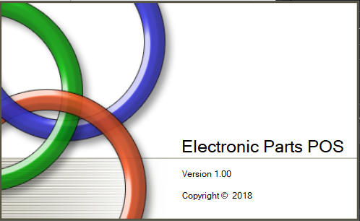

Figure 5.0

Splash screen

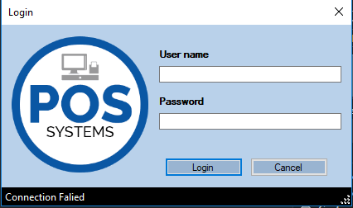

Figure 5.1

Login Screen (Admin and its users can login)

**11**

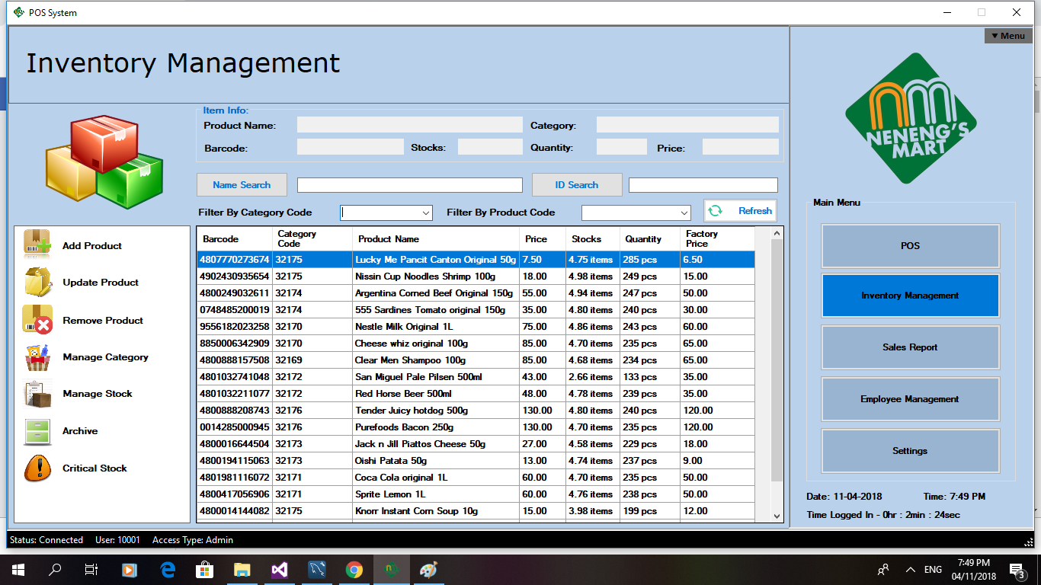

Figure 5.2

Main UI of the inventory management

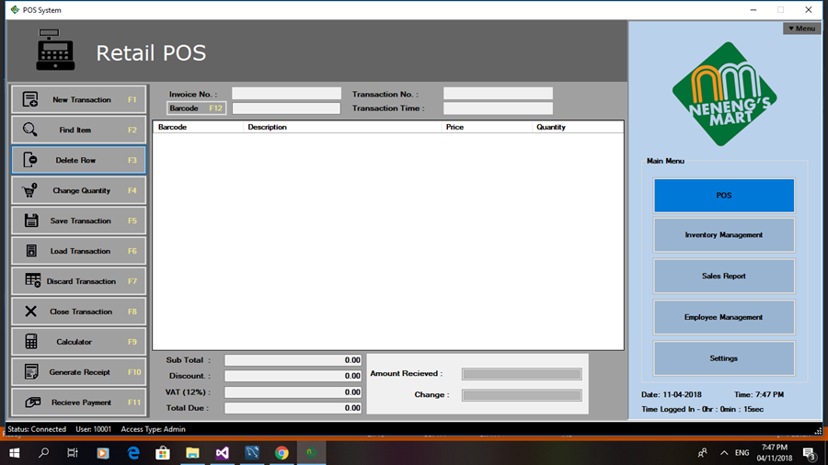

Figure 5.3

Main UI of POS system

**12**

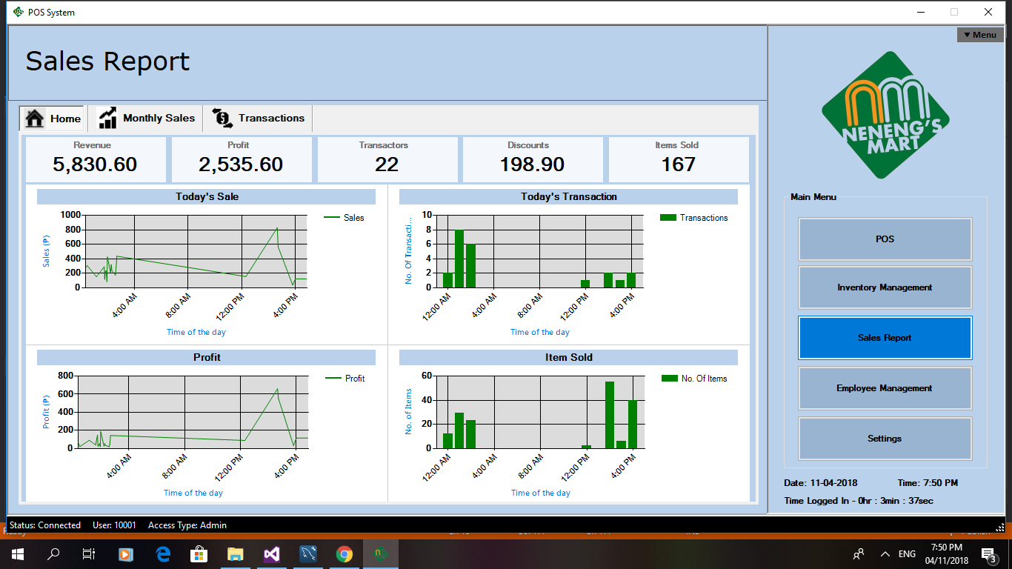

Figure 5.4

Sales report UI

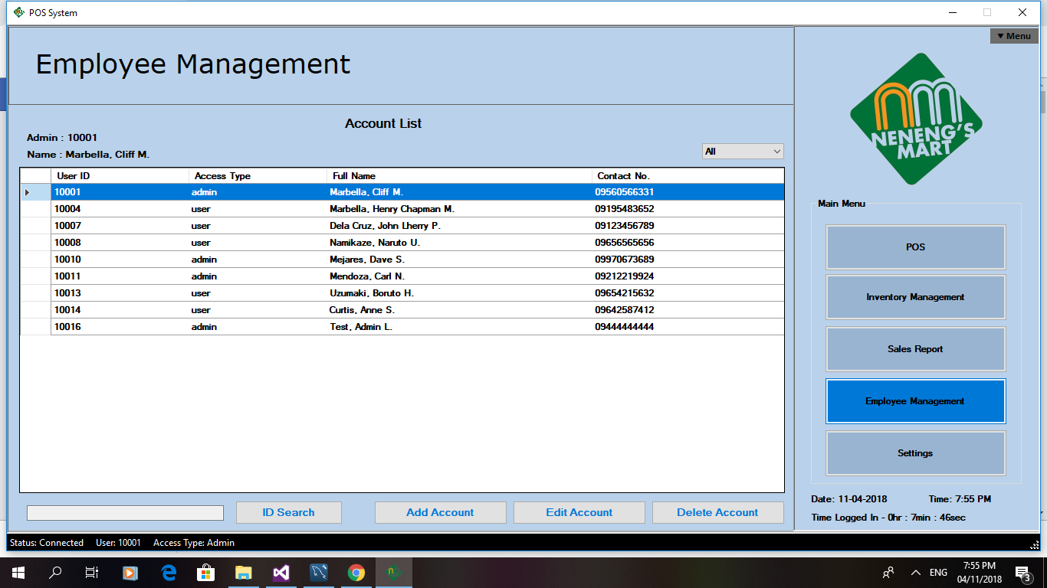

Figure 5.5

Employee management UI

**13**

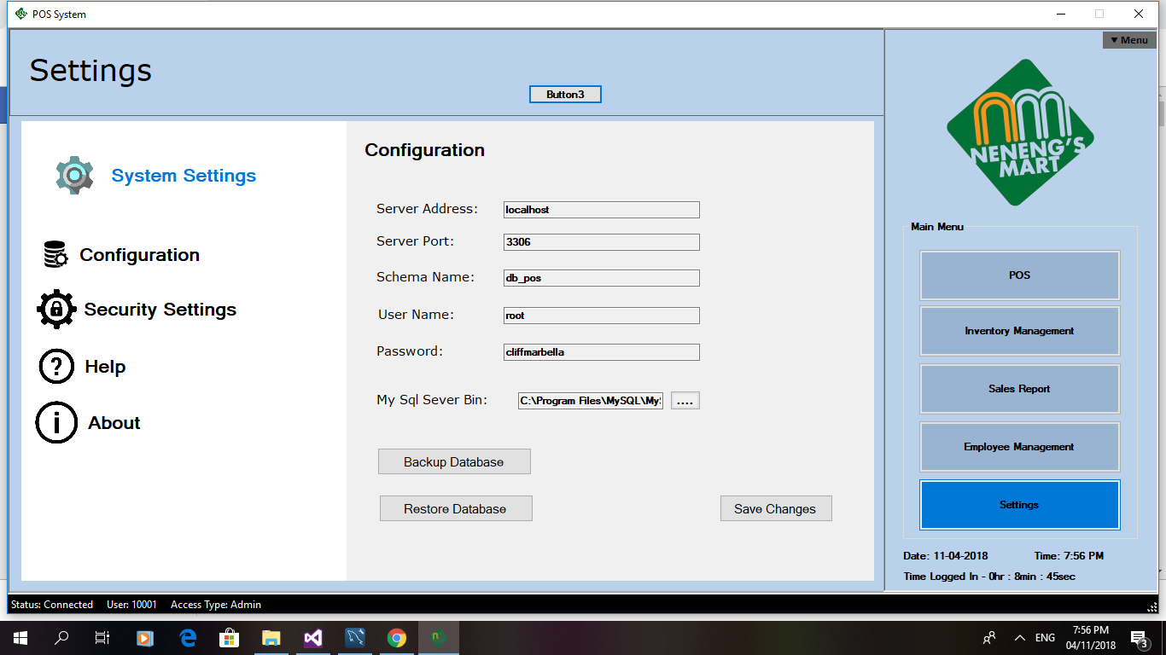

Figure 5.6

Settings UI

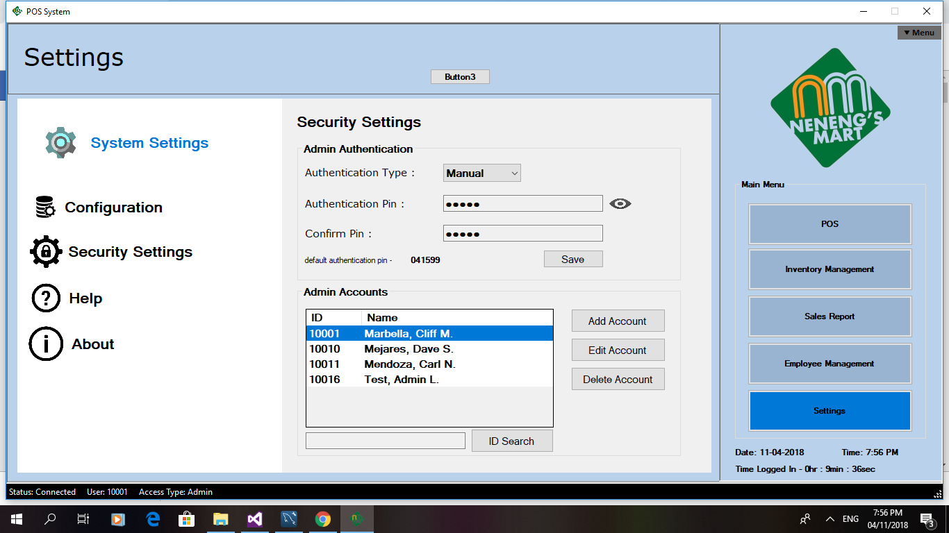

Figure 5.7

Security Settings

**14**

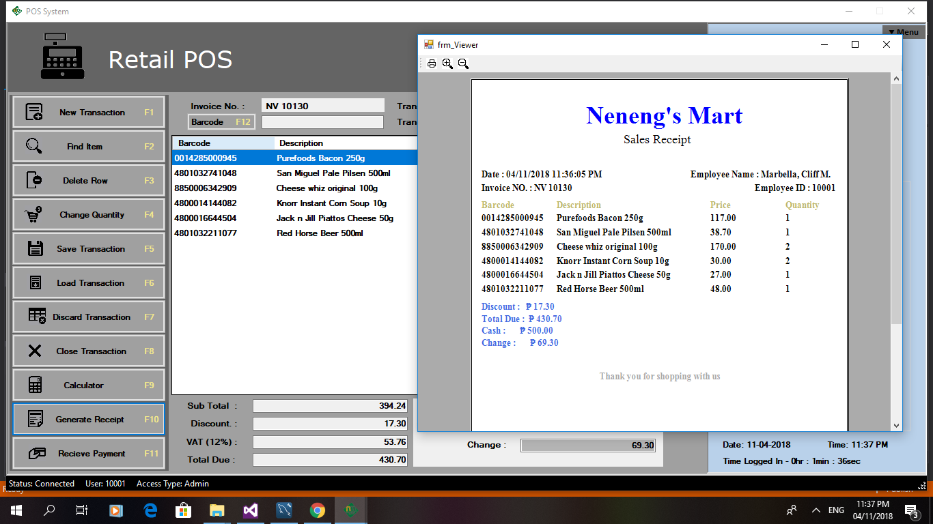

Figure 5.8

Sample Receipt



Figure 5.9

Employee Management

**15**

**5.5 Form/Report Specifications**

The group covers both the POS and the inventory systems. POS system and inventory system are different with each other. POS system will handle the customer’s transactions as well as the breakdown of items and payments while inventory management will handle the stocks remaining. The system is also capable of generating sales reports and employee management. The system has a wide scope of features. This is why the group conducted many troubleshooting to make sure there will be no bugs at the end of the project.

**5.6 Module Specifications**

|  |  |  |
| --- | --- | --- |
| Module | Description | Program |
| Login | Login module | Login |
| Employee | Employee time in and time out | Employee mangement |
| Employee logs | List if employee logs | Employee management |
| Point of Sales | To make interactions with the customer and be able to record and generate transactions | POS |
| Inventory | To see the lists of stocks. As well as adding, editing and deleting the desired product | Inventory management |
| Sales | To generate sales report. To monitor the profit, loss and average sales | Sales management |
| Backup and restore | To backup and restore the database information | Settings |

(Table 1 module specifications)

**6.0 System Coding**

**6.1 Programming language**

Our Group decided to use the language of visual basic vb.net. It had a numerous number of advantages to our creation of POS and inventory systems. Visual basic programming language it allows to create a software interface and codes in an easy to use graphical environment. VB is the combination of different components that are used on forms having specific attributes and actions with the help of those components. On the one hand it allows to develop windows based applications rapidly. One of the most important things to be considered with regard to programming in Visual basic is that the structure of VB is designed in a way that allows programmers to create executable code – Exe files. It enables programmers to develop programs that can be used as front end to databases. Besides, it’s with the help of visual basic tools, one can change the abstract ideas into programs or into the whole software while it allows revising and modifying the programs fittingly.

**16**

**6.2 Special Purpose Language Tools**

Our Group decided to use Mysql as a relational database management system. We used mainly because of MySQL allows multiple users to access to a variety of databases.Its SQL interpreter, Management components, GUI database viewers, stored procedures, cross-platform support, multiple CPU usage, client server system, session monitoring tools all help you to work and receive data in an efficient, stable and organized manner.

**7.0 System Testing Plan**

**7.1 Testing Stages**

|  |  |  |
| --- | --- | --- |
| Phase | Activity | Report |
| Unit testing | Checking of individual specific units for POS system | All units are in mint and working as tested. |
| Integration Testing | Testing process where individual units are combined and tested as a group. The purpose of this level of testing is to expose faults in the interaction between integrated units. | The units are working seamlessly. |
| System testing | The process where a complete, integrated system is tested. The purpose of this test is to evaluate the system’s compliance with the specified requirements. | No system bugs as tested  No found errors regarding the overall system. |
| Acceptance Testing | To test and evaluate the system’s compliance with the business requirements and assess whether it is acceptable for implementation. | The owner accepted but UI improvements must be done according to them. |

Table 2 Testing Stages

**7.2 Testing Schedules**

|  |  |  |  |  |  |  |  |  |  |  |  |  |
| --- | --- | --- | --- | --- | --- | --- | --- | --- | --- | --- | --- | --- |
|  | **9/10** | **9/**  **17** | **9/**  **24** | **9/**  **30** | **10/**  **7** | **10/**  **14** | **10/**  **21** | **10/**  **28** | **11/**  **4** | **11/11** | **11/18** | **11/25** |
| **Requirement**  **Gathering** |  |  |  |  |  |  |  |  |  |  |  |  |
| **Unit Testing** |  |  |  |  |  |  |  |  |  |  |  |  |
| **Integration Testing** |  |  |  |  |  |  |  |  |  |  |  |  |
| **System Testing** |  |  |  |  |  |  |  |  |  |  |  |  |
| **Acceptance testing** |  |  |  |  |  |  |  |  |  |  |  |  |

**17**

**8.0 System Implementation Plan**

**8.1 Resource Requirements**

A list of hardware or software items needed to accomplish a task. The memory and disk capacities in a computer are necessary to run an application. In the early days of PCs, the hardware interrupts and channels in the computer that had to be configured when adding new peripheral devices.

**8.1.1 Hardware Requirements**

|  |  |
| --- | --- |
| **Minimum** | **Recommended** |
| **CPU info: Intel i3** | **CPU info: Intel i5** |
| **RAM: 512mb** | **RAM: 2gb** |
| **CPU speed: 1.5 GHz** | **CPU speed: 2.0 GHz** |

Table 3: Hardware requirements

**8.1.2 Software Requirements (recommended)**

* Visual Basic (2017)
* Microsoft Word (2015)
* MySql ver 6.3
* Windows 7 (32/64-bit)

**8.1.3 Human Resource Requirements**

* Cashier Staff – Will only handle the POS system. The cashier staff should handle customer’s transactions.
* Admin – The admin has the privilege to access both POS systems and Inventory management as well the Sales report. Employee management and the Systems settings

**8.2 Implementation Plan**

**8.2.1 Site Preparation**

Located in 350 Silangan, Sto. Nino, Calumpit, Bulacan. The group provided all the necessary requirements to implement our newly created system to their computer. Our first plan is to secure whether their PC meets all the Hardware requirements

* Developer Address: McArthur Hiway, Pio Cruzcosa, Calumpit Bulacan.

**8.2.2 Personal Training**

The group is also in charge of teaching on how our system will work and how to operate it on a proper way. Our group member Cliff Marbella the lead programmer of our project, provided all the information and each of the system’s individual buttons and their functions.

* Mrs Apple Salonga – Owner (Administrator)
* Mariedeth Cruz Abad – Cashier (Staff)

**18**

**8.2.3 System Conversion**

A user friendly computerized store inventory system has been developed in Visual Basic after studying the current store system of the Neneng’s Mart . The proposed software can help improve the efficiency of the store. It is timeliness, accurate, reliable, consistent, faster, efficient and easy to use. Removal of redundancy/duplication and irrelevance are some of the other benefits. It can be easily tailored for multiuser environment with minor modifications.

**8.2.4 Data Conversion**

Inventory Advisors has the knowledge and experience to quickly and properly get your data into the systems we offer, getting the conversion right the very first time and saving you time and money by allowing your staff to focus on their work tasks and on learning how to use the new system.

**8.2.5 Implementation Schedule**

The following are important steps for implementation:

* Assign responsibility–without this nothing may get done;
* Analyze the needs of the store ;
* Establish the minimum stock neededfor an appropriate time period;
* Develop needed forms and logs;
* Establish a system for receiving, inspecting, and storing supplies;
* Maintain an inventory system in all storage areas, and for all reagents and supplies used in the store

**9.0 System Maintenance Plan**

|  |  |
| --- | --- |
| Produce annual report | * The goal here is to inspect both hardware and software. For example if a system has occurring bugs or if it has hardware related problems |
| Short Term Plan | * To avoid stockouts, you should establish a minimum and a maximum inventory level for each part. * To detect issues early, before they become problems * To maximize software efficiency |
| Long  Term Plan | * The purpose of cycle counts is to verify inventory accuracy with a physical count and correct any discrepancies between what’s in the system and what’s actually available. |

**Table 4  
Maintenance Plan Table**

**19**

**STI College Malolos**

**Point of Service System (POS) with Inventory Management System for Neneng’s Mart**

A Research Proposal Presented to

the Faculty of STI College Malolos

In Partial Fulfillment

of the Requirements for the Degree of

Bachelor of Science in Computer Engineering

By:

De Guzman,Rainier

Marbella, Cliff

Mejares, Dave Lemuel

Mendoza, Carl Lloyd

Ms. Joy Balbin

Adviser

November 11,2018

**SYSTEM ANALYSIS AND DESIGN PROJECT**

List of Figures  
List of Tables  
List of Appendices

**TABLE OF CONTENTS**

1. INTRODUCTION 1

1.1 Background of the Study 1

1.2 Statement of the Objectives 2

1.2.1 General Objective 2   
 1.2.2Specific objective 2   
 1.3 Significance of the study 2

1.4 Scope and Limitation of the Study 3  
 2.0 Methodology of the study 3  
 3.0 Data Gathering Procedures and Output 4 4.0 The Existing System 5  
 4.1 Company Background 5  
 4.2 Description of the System 5

4.3 Data Flow Diagram 6

4.4 Data Dictionary 6  
 4.5 Problem Areas 7

5.0 The Proposed System 7

5.1 System Overview 7  
 5.2 Process Specification 8

5.2.1 Data Flow Diagram 8  
 5.2.2 Data Dictionary 8  
 5.3 Data Specification 10  
 5.3.1 Entity Relationship Diagram 10  
 5.4 Screen Layout / Specifications 11  
 5.5 Report / Form Specification 16  
 5.6 Program / Module Specification 16  
 6.0 System Coding (Prototype) 16  
 6.1 Programming Language 16  
 6.2 Special Purpose Language Tools 17

7.0 System Testing Plan 17

7.1 Testing Stages 17  
 7.2 Testing Schedules 17  
 8.0 System Implementation 18  
 8.1 Resource Requirements 18  
 8.1.1 Hardware Requirements  
 8.1.2 Software Requirements

8.1.3 Human Resource Requirements

8.2 Implementation Plan 18

8.2.1 Site Preparation

8.2.2 Personal Training  
 8.2.3 System Conversion  
 8.2.4 Data Conversion  
 8.2.5 Implementation Schedule  
 9.0 System Maintenance Plan 19

Appendices

Bibliography

Resource Persons

**List of tables**

Table 1 Module specifications 16

Table 2 Testing Stages 17

Table 3 Hardware Requirements 18

Table 4 Maintenance Plan Table 19

**List of figures**

Spiral Method (fig.1.0) 3

Figure 2.0 Data flow diagram 6

Figure 3.0: POS Data flow Diagram 8

Figure 4.0: Entity Relationship Diagram 10

Figure 5.0 Splash screen 11

Figure 5.1 Login Screen 11

Figure 5.2 Main UI of the inventory management 12

Figure 5.3 Main UI of POS system 12

Figure 5.4 Sales report UI 13

Figure 5.5 Employee management UI 13

Figure 5.6 Settings UI 14

Figure 5.7 Security Settings 14

Figure 5.8 Sample Receipt 15

Figure 5.9 Employee Management 15

APPENDICES

**Schedule of the activities**

|  |  |  |  |  |  |  |
| --- | --- | --- | --- | --- | --- | --- |
| July | | | | | | |
| Monday | Tuesday | Wednesday | Thursday | Friday | Saturday | Sunday |
|  |  |  |  |  |  | 1 |
| 2 | 3 | 4 | 5 | 6 | 7 | 8 |
| 9 | 10 Announcement of Project | 11 | 12 Planning  Of the project | 13 | 14 | 15 |
| 16 | 17 | 18 | 19 | 20 | 21 | 22 Start of interview |
| 23 | 24 | 25 Start of the project | 26 | 27 | 28 | 29 |
| 30 | 31 |

|  |  |  |  |  |  |  |
| --- | --- | --- | --- | --- | --- | --- |
| **August** | | | | | | |
| Monday | Tuesday | Wednesday | Thursday | Friday | Saturday | Sunday |
|  |  | **1** | **2** | **3** | **4** | **5** |
| **6** | **7** | **8** | **9** | **10** 1st practical defense | **11** | **12** |
| **13** | **14** | **15** | **16** | **17** | **18** | **19** |
| **20** | **21** | **22** | **23** | **24** | **25** | **26** |
| **27** | **28** | **29** | **30** | **31** |  |  |

|  |  |  |  |  |  |  |
| --- | --- | --- | --- | --- | --- | --- |
| **September** | | | | | | |
| Monday | Tuesday | Wednesday | Thursday | Friday | Saturday | Sunday |
|  |  |  |  |  | **1** | **2** |
| **3** | **4** | **5** | **6** | **7** | **8** | **9** |
| **10** | **11** | **12** | **13** | **14** | **15** | **16** |
| **17** | **18** | **19** | **20** | **21** | **22** | **23** |
| **24** | **25** | **26** | **27** Project passing 50% | **28** | **29** | **30** |

|  |  |  |  |  |  |  |
| --- | --- | --- | --- | --- | --- | --- |
| **October** | | | | | | |
| Monday | Tuesday | Wednesday | Thursday | Friday | Saturday | Sunday |
| **1** | **2** | **3** | **4** | **5** | **6** | **7** |
| **8** | **9** | **10** | **11** | **12** | **13** | **14** |
| **15** | **16** | **17** | **18** | **19** | **20** | **21** |
| **22** | **23** | **24** | **25** | **26** | **27** | **28** |
| **29** | **30** | **31** |  |  |  |  |

|  |  |  |  |  |  |  |  |  |  |  |  |  |  |  |  |  |  |
| --- | --- | --- | --- | --- | --- | --- | --- | --- | --- | --- | --- | --- | --- | --- | --- | --- | --- |
|  | **7/10** | **7/**  **17** | **7/**  **24** | **7/**  **31** | **8/**  **7** | **8/**  **14** | **8/**  **21** | **8/**  **28** | **9/**  **4** | **9/11** | **9/18** | **9/25** | **10/**  **2** | **10/**  **12** | **10/**  **22** | **10/**  **31** |  |
| **Requirement**  **Gathering** |  |  |  |  |  |  |  |  |  |  |  |  |  |  |  |  |  |
| **Planning** |  |  |  |  |  |  |  |  |  |  |  |  |  |  |  |  |  |
| **Designing** |  |  |  |  |  |  |  |  |  |  |  |  |  |  |  |  |  |
| **Coding** |  |  |  |  |  |  |  |  |  |  |  |  |  |  |  |  |  |
| **Documentation** |  |  |  |  |  |  |  |  |  |  |  |  |  |  |  |  |  |